New Mobile Pantry Food Distribution!

Join us for a new food Distribution located in CITY/AREA!

Every 2nd & 4th
Saturday
AGENCY NAME is hosting a Forgotten Harvest Food Distribution for the public. To keep everyone safe, please have your trunk space clear. INCLUDE ANY SITE OR TRAFFIC DIRECTIONS HERE
STarting May 14th
00:00 am to 00:00 pm
or until food runs out
Location Name
Address, City
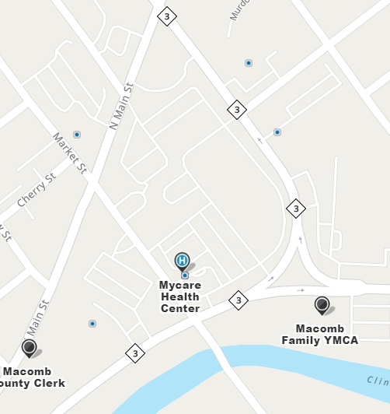
Insert your own map here…
Northbound Gratiot

