Forgotten Harvest Agency Resource Manual

15000 W. Eight Mile Road, Oak Park MI | 248.967.1500 | ForgottenHarvest.org

Updated August 2022

Table of Contents

⸙ Welcome Letter
⸙ Introduction to Forgotten Harvest
Our Purpose
Our Mission
Our Vision
Solutions that Nourish
⸙ Leadership
⸙ Agency Eligibility
⸙ New Distribution Planning
Pre-Launch Needs and Work
Volunteer Planning
Marketing
⸙ Policies for Food Distributions
⸙ Client Intake and Registration Processes
⸙ Food Distributions
⸙ Volunteer Process and Orientation
⸙ Food Safety Information
⸙ Monitoring and Compliance
⸙ Resources

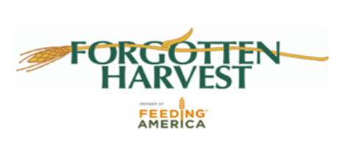

Welcome to Forgotten Harvest…
As a partner Agency to Forgotten Harvest, we want to first thank you for your partnership and dedication to ending hunger in our community. Without the work you and our many other partners do, Forgotten Harvest would not be able to fulfill our Mission of relieving hunger and preventing nutritious food waste in our community.
This resource is used to provides partner agencies with the tools and knowledge needed to achieve compliance requirements and to successful manage a distribution. It details policies enforced by Forgotten Harvest, as a requirement of the USDA and Feeding America.
As a member of the Feeding America network, Forgotten Harvest is held accountable to a strict set of rules and governing procedures that ensure food is distributed safely as it pertains to State, IRS, and Federal law. Accordingly, we expect each partner agency to follow the policies and procedures outlined not only in this handbook, but also the guidelines set forth in the Forgotten Harvest Agency Agreement and any of the appropriate appendices.
This handbook serves to address and answer any questions that may arise as a condition of partnership with the us. It will guide agencies and help to build a better understanding of the standards and regulations. Forgotten Harvest will make every effort to notify partner agencies when official changes in policy or procedure have been made.

Your Client Services Team,

Kelli Kaschimer Robbya DuBose
Director, Volunteer and Client Services Client Service Specialist

Krista Poole Leslie Quasarano
Manager, Client Services Client Service Specialist

Dawn Sketch
Client Service Specialist

15000 W. Eight Mile Rd. | Oak Park, MI 48237 | (248) 967-1500 | www.forgottenharvest.org
uction to Footten Harvest
Our Purpose
For over 30 years, Forgotten Harvest has fought two problems: hunger and waste.
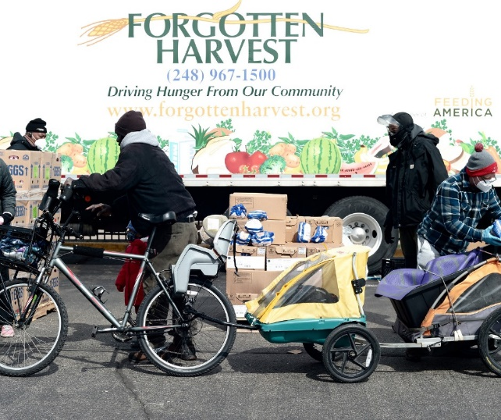
In 1990, we set down roots in the greater metro Detroit area and began rescuing food surpluses from grocery stores, markets, restaurants, caterers, and more. We took donated food, which would otherwise go to waste, and delivered it free-of-charge to emergency food providers in the metro Detroit area. Our work has since expanded to include Forgotten Harvest Farms, where we grow our own fresh food for those in need.
All the food we rescue and produce is delivered to metro Detroit families who are food-insecure and struggle to cover the cost of basic life necessities. Our food helps bridge the income gap for tens of thousands of people, allowing them to secure some basic life necessities for themselves and their family.
Our Mission
We are dedicated to relieving hunger and preventing nutritious food waste.

Our Vision
We envision communities that work together to end hunger and increase individual, neighborhood, economic, and environmental health.

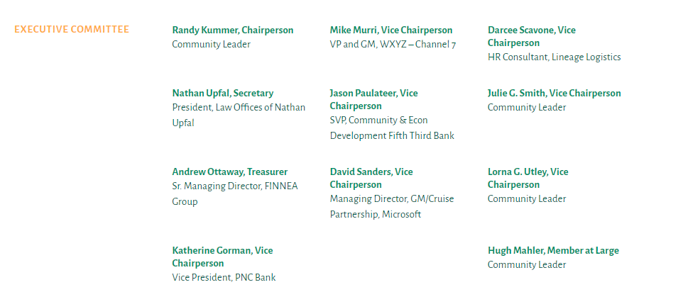
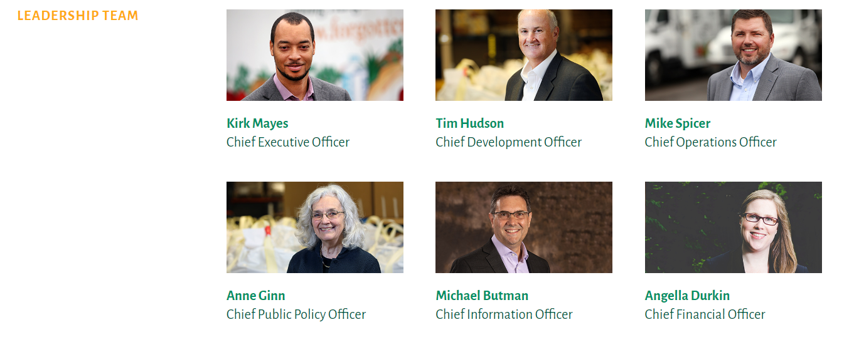
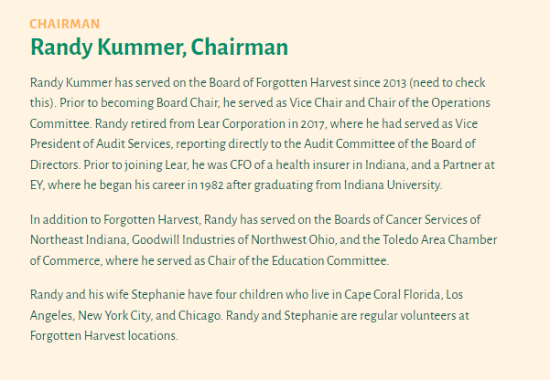

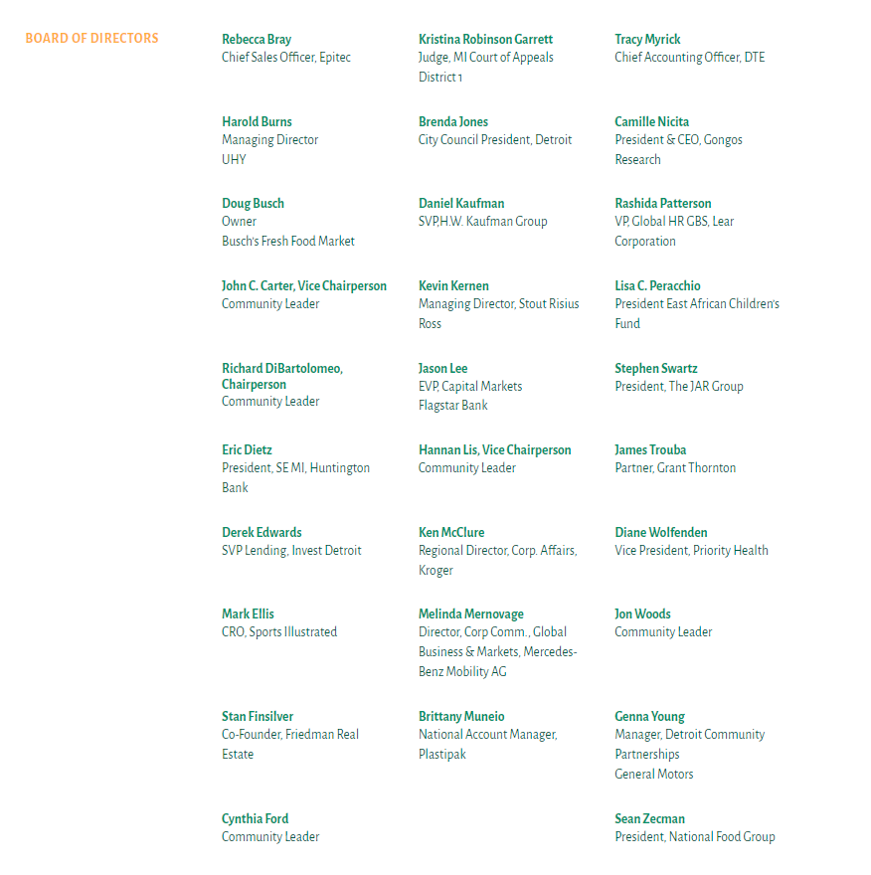

Agency Eligibility

Here at Forgotten Harvest, we distribute food daily to almost 200 agencies of soup kitchens, emergency food pantries, senior centers, children’s homes, domestic shelters, homeless shelters, group homes, and more. In order to be considered as an agency, an organization must meet specific criteria that will help to ensure that the partnership will further the mission and the work of Forgotten Harvest.

Priority is given to agencies serving vulnerable populations, including at-risk children, frail seniors, and homeless families. Other factors in the selection process include the agency’s service to high-poverty areas and frequency of service/capacity for distribution of perishable foods. Using Census data, we can identify, to the block level, the highest concentrations of poverty in the tri-county area. Priority is given to agencies serving the greatest number of families with children in these neighborhoods. On top of these factors, partners must also:

- In the future state for Forgotten Harvest, Agencies will need to provide service on at least a twice a month basis and be able to take delivery of food at least every other week
- Be a 501(c)(3) nonprofit organization with proof of status from IRS
- Have a ServSafe Manager Certification (if preparing food) or ServSafe Food Handler Certificate or equivalent if keeping food on site
- Facilitate and gather accurate data capture at each distribution through Link 2 Feed System
- Have an identified and named onsite Pantry Manager/Lead
- Have on-site refrigeration for storage of perishable foods (only for non-mobile pantries)
- Sign and adhere to Forgotten Harvest Agency Agreement
- Allow for yearly onsite Audit from Forgotten Harvest Staff
- Complete and Adhere to annual Civil Rights Training for your distribution

Additionally, to be considered and maintain compliance for a Mobile Panty Distribution (our largest distributions), an agency must:
- Sign and Adhere to Forgotten Harvest Agency Agreement
- Have an identified and named onsite distribution lead
- Enough space/road/lot to safely process 100-800 cars per distribution without impacting local traffic
- Parking Lot/Space that can accommodate a Semi Truck or Large Box Truck
- Surface area that is flat and free from holes/damage so that a pallet jack can safely operate
- Recruitment and management of volunteers for distributions (Approx. 15-20 volunteers)
- Facilitate and gather accurate data capture at each distribution through Link 2 Feed System to be submitted no later than 48 hours after distribution
- Internet/Wi-Fi service at distribution site is preferable
- Restroom facilities available for FH staff and Volunteers

New Distribution Launch Planning and Considerations for Mobile Pantries:
Starting a new distribution can seem overwhelming at first, but it is important to know that you are not in this alone. You will have a specific Forgotten Harvest Client Service Specialist to guide you through your launch and throughout your partnership with us. Below you will find some of the considerations and plans that you should have laid out prior to your distribution to ensure for a smooth and successful launch. Once you have your first distribution planned and scheduled you should begin the following:

Pre- Launch Communications Prep Work:
- Work with your local neighborhood, congregations, and municipality to share the information about your food distribution
- While sharing information about the food availability, you can also solicit for volunteers from this same group
- Plan and schedule a meeting with all confirmed and potential volunteers (see below for further detail)
- Print all necessary volunteer waivers, sign-in sheets and Client Intake Forms
Volunteer Planning:
- Recruitment: In order to have a successful distribution you will need volunteers to help. Work with your Client Services Specialist to determine the number of volunteers you will need.
  - Mobile Pantries typically use 20-30 volunteers
  - Food Pantries may need 2-10 (depending on how many clients are being served at one time)
- Shift/Duties: Breakdown the times and duties for each volunteer role.
  - Let your volunteers choose their roles so it is something they are comfortable with.
  - Recommended Roles for a Mobile Distribution:
    - Client Intake: 2-4 people
    - Food Distribution: 10-12 people
    - Walk Up Clients: 1-2 people
    - Traffic Direction: 1-2 people (police are great for this if they are available)
    - Runners (fill in for any role): 1-2 people
    - Post Distribution Data Entry: 1-2 people
- Arrival times: Communicate to your volunteers a clear arrival time, parking location and any other specifics for your distribution. We recommend that volunteers arrive 30 min. to an hour before distribution begins. Some food items may require bagging. As your distributions go on, you can adjust this start time as your volunteers become more comfortable and knowledgeable in their roles.
  - If you are not able to have a meeting before the distribution, you may want them to arrive earlier so you can do it onsite that day.
- Food for Volunteers Policy: Many of our volunteers are also in need of food, please make sure they know that they are indeed able to get food for their home, but make sure all volunteers understand your volunteer food distribution policy (see page 22)

Training: Plan a pre-distribution meeting with your volunteers to talk through each of the roles and what the distribution will look like. This training can be done in person or virtual. You should invite your Client Service Specialist to join you for this meeting. Agenda may include:
- Civil Rights Training
- Roles and Needs Overview
- Day of expectations
- Dress code (No open toe shoes, dress weather appropriate, etc.)
Distribution Site Needs and Considerations:
- You will need a space that can accommodate at least 10 cars to drive through and stop at each pallet of food. Pallets should be placed 3-5 feet apart in order to leave enough room for volunteers to step between and move products as well as for cars to pull up to each station one at a time.
  - Volunteers should allow cars to come to them at the station they are assigned. This will help with a continuous traffic flow, ensure every client gets each item and helps protect our volunteers.
- Create a plan in place for clients who walk up to your mobile pantry.
  - Sometimes these clients are only able to take/carry a certain amount of food, so please work with them to determine what items they may need the most or are most important to them if space is a constraint.
  - Clients should NOT touch or “shop” the food at food stations.
  - Assign a volunteer to assist these clients specifically. They will walk the line with the client and pull the food to be placed in the client’s box/wagon/etc.
  - Maintain a safe distance between clients on foot and the moving cars in line.
- Unfortunately, all good things must come to an end… at the end of your distribution time slot we do need to end the actual distribution. You will need to have someone assigned to monitor the line and decide when (if necessary) to turn clients away due to either timing or availability of remaining food.
  - We suggest having traffic cones or other signage to “cut off” the end of the line when you are ready to end the distribution
  - Have 2 assigned volunteers that can address any clients that pull up after this point. Let them know you are closed for today but would love to see you at our next distribution (Provide the date and times).
  - In addition to that, if client is really in need, please direct them to the Forgotten Harvest Website or direct them to call 248-967-1500 to locate the nearest and soonest pantry.
- Forgotten Harvest supplies food and resources to many pantries each day and we have limited resources. If a driver and their truck is held up at one location, it will create a late arrival for their next distribution.
  - Any un-distributed food needs to be loaded back onto the truck
  - Garbage/Dunnage will go back onto the truck- See Dunnage How to Document for more direction

Marketing and Community Outreach:
You can have the food, the volunteers and the perfect space to host a distribution for your community, but it’s just as important to make sure your community knows to come to you! While Forgotten Harvest will list your distribution on our website, keep the information updated in our weekly Find Food updates and will post all Mobile Pantry Distributions on our social media accounts daily, you as a member of your own community have a MUCH larger network and ability to reach your community then we do! It is also important to think broadly about this and how to reach people outside of your “inner circle”. You may think that everyone knows about your distribution, but unless someone was in need themselves the first time you told them, it may or may not have resonated with them at that time. There are many ways to do this, and some ideas are included below:
- Work with local elected officials and community members, ask them to share about the distribution within their networks or with their constituents. Many constituents may go to them when seeking resources, make sure they know that you are one of the resources they can refer people to when they are looking for food.
- Create a flyer that can be used to post in public places, on social media and sent out through various email lists (see our resources at the end of the manual for a sample/template!)
- Post a flyer/notice in public places (think about libraries, schools, community centers, bulletin boards, etc)
- Reach out to your local neighborhood or city media/news to let them know about your distribution, ask them to run a story!
- Flyer your neighborhood or the neighborhood(s) surrounding your location! There is nothing better then telling the people right where they live how to get help, and even better when it is in walking distance to their home!
- Include a standing notice on any newsletter or publications from your organization about your food Distribution. Even a simple “Food Distribution: Mondays from 2:00-4:00” will do!
- If you are part of a religious organization, have a reminder announced during service (you can do the same thing to recruit volunteers to help as well!)
- Have Food Distribution signs on your property and at main roads to catch the public during your distributions (you can get these from Forgotten Harvest through your Client Service Specialist)
- If you have the resources, creating a video about your distribution is a great way to let people know about what you are doing and how it impacts the community.
- Social Media:
  - Many communities have resident sites on Facebook and other social media. Try looking for pages or groups related to “XXX Community”, Residents of XXX, Free or Garage Sale Sites or even alumni groups from the local schools. This is a fantastic way to reach people outside of your inner network.
  - Find a volunteer who is well versed on Social Media... make sure you are sharing your distribution information within all the relevant groups and pages on social media.
  - Ask others to share on their social media platforms, friends of friends have a completely different network than you!

Sample Posts for Social Media….
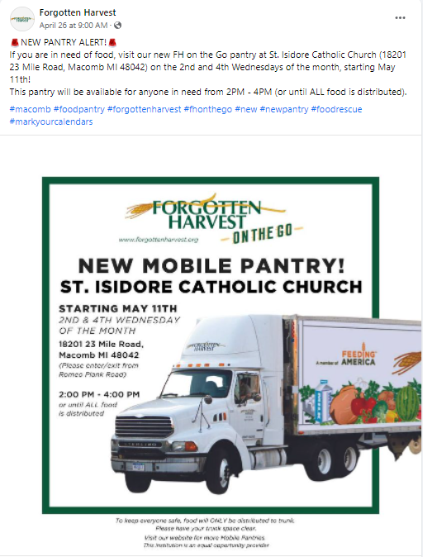
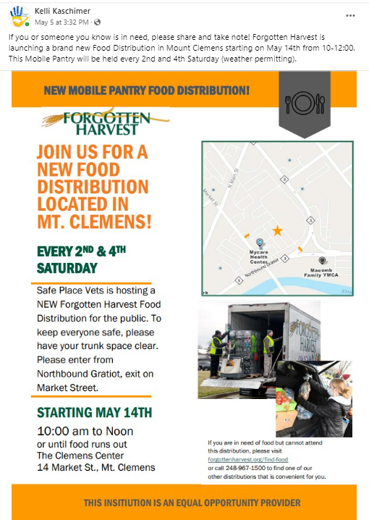

Policies for Food Distributions and Agency Partnerships

Non-Discrimination Policy
Partners are required to serve clients in an inclusive and non-discriminatory manner and cannot deny access to anyone based off of race, ethnicity, gender, socio-economic status, physical or mental ability, religious belief, national origin, citizenship, ancestry, age, marital status, familial or parental status, sexual orientation including gender identity or expression, political viewpoints and other ideologies, or discharge status from the military or status as a protected veteran. All partners are required to complete Civil Rights training biennially. Partners participating in The Emergency Food Assistance Program (TEFAP) must also complete Civil Rights training annually.
Your pantry will be provided with a “Justice for All” poster. This poster MUST be displayed at your pantry at the time of any distribution if you are receiving and providing USDA food. If your pantry needs this poster in a language in addition to English and Spanish, it can be provided upon request.
Civil Rights Training
All Agency Partners that receive USDA/TEFAP or SFSP/CACFP product must adhere to an annual Civil Rights training for all volunteers with any involvement with the food distribution.
- Civil Rights training is to be completed by all staff or volunteers involved in all levels of the TEFAP and/or CSFP distribution or who interact with program participants on an annual basis.
- All staff and volunteers are to complete the MDE PowerPoint training on the Food Distribution website – www.michigan.gov/mde-fdp during the month of September. Copies of course completion certificates are to be kept on file in the program manager’s office.
- All new food distribution employees and volunteers are to complete the MDE training upon hire.

Day of Distribution - Civil Rights Training
Some of our distribution sites are large enough that we have groups of volunteers who come and help just for the day. In these cases, the site manager will go over the day of distribution Civil Rights training with the one-day volunteers. The volunteers will collectively sign a dated copy of the attached training (located in the resource section of this manual). These should be stored in the program manager’s office.

USDA Nondiscrimination Statement
The most current long version of the USDA nondiscrimination statement will always be posted when applying for program benefits and when signing for food. It should also be posted on the food programs page of the agency website or were applicable:
Long Version:
In accordance with federal civil rights law and U.S. Department of Agriculture (USDA) civil rights regulations and policies, the USDA, its Agencies, offices, and employees, and institutions participating in or administering USDA programs are prohibited from discriminating based on race, color, national origin, sex, disability, age, or reprisal or retaliation for prior civil rights activity in any program or activity conducted or funded by USDA.
Persons with disabilities who require alternative means of communication for program information (e.g., Braille, large print, audiotape, American Sign Language), should contact the agency (state or local) where they applied for benefits. Individuals who are deaf, hard of hearing or have speech disabilities may contact USDA through the Federal Relay Service at (800) 877-8339. Additionally, program information may be made available in languages other than English.
To file a program complaint of discrimination, complete the USDA Program Discrimination Complaint Form, (AD-3027) found online at: How to File a Complaint, and at any USDA office, or write a letter addressed to USDA and provide in the letter all of the information requested in the form. To request a copy of the complaint form, call (866) 632-9992. Submit your completed form or letter to USDA by:
- mail: U.S. Department of Agriculture
Office of the Assistant Secretary for Civil Rights
1400 Independence Avenue, SW
Washington, D.C. 20250-9410;
- fax: (202) 690-7442; or
- email: program.intake@usda.gov.
Short Version
The short version of the USDA nondiscrimination statement MUST be included on all program materials including but not limited to, flyers, distribution schedules, and nutrition education. That statement is:
This institution is an equal opportunity provider.
And Justice for All Poster
The current And Justice for All poster will be prominently displayed at all sites during certification and distribution. Laminated copies will be made available to all sites.

Limited English Proficiency Plan
According to the latest Census data, our county has many Spanish speaking residents. As such, our Agency will provide translated copies of all food distribution materials, including but not limited to – self declaration forms, CSFP applications, distribution schedules, and nutrition education.
The program manager will work with the agency officer to review census data for the service area on an annual basis. If there is a population of limited English speakers of 5% or more, program materials will be translated and information will be distributed to local organizations.
Each site will provide its own list of translators if they have them. Each distribution site will have ISpeak Language Statements for helping to identify language needs. If there are no translators on site and it is Spanish that is needed, the site can call the main MDE office. If it is a different language, the site can either use Google Translate or call 1-800-translate for assistance.
Children are never to be used as translators in matters of participant intake and/or benefit issuances.

Civil Rights Complaints
All Civil Rights complaints will be directed to the program manager who will follow up with the participant and provide them with information on filing a complaint. Civil Rights complaints are to be filed by downloading a form from the USDA Civil Rights website or by calling 866-632-9992 to request the complaint form.

Religiously Affiliated Distribution Sites
Potential distribution sites may not be denied based on religious affiliation. A faith-based organization does not have to remove any religious materials, art, or icons, but cannot distribute such as part of the food distribution. However, distribution must be available to all eligible participants, whether they are part of the organization or not.
During distribution at a faith-based organization, a Notice of Beneficiary Rights (see link located in resources) must be publicly posted. This states if someone does not want to pick up food from that site because of religious reasons, they can call the program manager for an alternate secular location.

Site Distribution Procedures
Site Distribution Procedures must be filled out and completed for all distributions. These procedures will be kept on file with Forgotten Harvest as well as the agency should retain a copy for their own use. This document can be used to help keep the food distribution happening in the appropriate and pre-planned ways specific to your site in the absence of the Program/Agency Manager or others who are familiar with the processes.

Hours Posted
All sites must have displayed to the public and clients during the actual distribution the hours of the distribution. It is suggested to include the hours (template located in the resources) in the same location as your “Justice for All” poster, Beneficiary Rights and other posted notices.
If you must cancel/close your food distribution at any of the regular times, you MIST notify Forgotten Harvest a minimum of 48 Hours prior to your scheduled delivery. If you know you will have a planned closure ahead of time, please let Forgotten Harvest know when that decision is made so that we can adequately redirected resources ahead of time. Additionally, you must put up a sign stating the closure and listing the next food distribution you will be open for.

No Solicitation of Clients
Products received from Forgotten Harvest must not be re-distributed, sold, bartered or traded to other organizations. Products received from Forgotten Harvest may not be used to solicit, request or require donations or support to receiving agency. All distributions must be given freely to any eligible recipient.

No Requirements from Clients
Agencies may NOT exclusively serve their membership, customers, clients or patrons and must be open to the general public. The agency cannot require eligible clients to perform services in exchange for donated products which includes but is not limited to volunteer service, parishionership, engagement or more.

No “other” use of Food
Products received from Forgotten Harvest may not be used for special events of any kind unless the event is approved by Client Services Manager and exclusively for the ill, needy and infants as per Section 170 (e) (3) of the Internal Revenue Service Code.

Inspection Requirements
Agency must permit on-site inspections by Forgotten Harvest representatives at their discretion. Refusal of inspection will place agency on hold and the agency will not receive food deliveries until inspection is completed. (See Monitoring and Inspections Section for more information).

ServSafe® Certification
ServSafe® is a food and beverage safety training and certificate program administered by the National Restaurant Association. The program is accredited by ANSI and the Conference for Food Protection. For agency partners to receive food from Forgotten Harvest, your agency must have a ServSafe Manager Certification or ServSafe Food Handler for Food Banking certificate (administered by Forgotten Harvest) on site at each location where we provide food. Facilities that are preparing and serving food provided by Forgotten Harvest, must have a ServSafe Manager on site during all preparation and distribution of food, regardless, if your facility is inspected by a local, regional, or state agency.

Religious Proselytizing
We recognize that many partners are located in and/or sponsored by a church or religious organization; however, partners cannot participate in religious proselytizing. This includes discriminating against clients based on faith or beliefs, requiring or requesting clients attend a service or other activity, or asking questions pertaining to religious affiliations verbally or on an intake form.

Client Confidentiality
Client privacy is one of the most important considerations for our partner network. Clients coming to food pantries, meal sites, and shelters feel anxious, and many are struggling to keep their food insecurity secret from their children, some family members, their employer, colleagues, or friends. We must do whatever we can to have practices in place to ensure client confidentiality, so people feel welcome to ask for and receive the help they need. If you’re uncertain whether you should share information, err on the side of caution and compassion for the client.
When registering clients, you may be asking them for information that is confidential, including address, phone number and email address. This information may ONLY be used to contact clients regarding the food distributions or changes (closed for weather, holidays, a change in service time or similar topics). Respecting the privacy of our clients, donors, and volunteers is essential to Forgotten Harvest. Personal and financial information is confidential and should not be disclosed or discussed with anyone without permission or authorization from Leadership at Forgotten Harvest. Care shall also be taken to ensure that unauthorized individuals do not overhear any discussion of confidential information and that documents containing confidential information are not left in the open or inadvertently shared.

Sample A Frame Board that should be displayed at distributions:
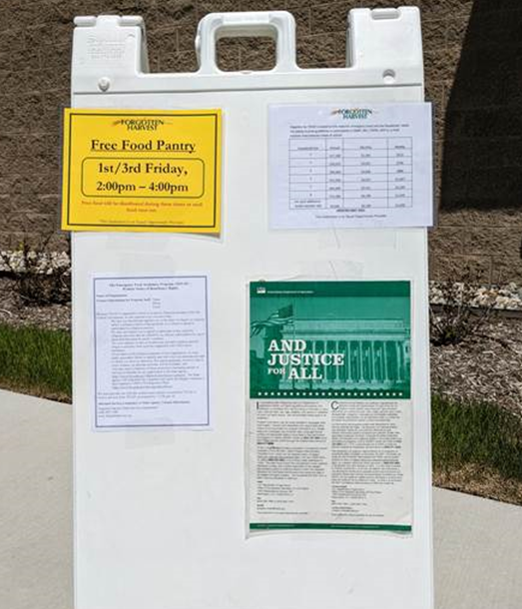

All Distributions MUST post:
- Hours of Distribution
- TEFAP Eligibility Guidelines
- Justice for All USDA/TEFAP Poster
Additionally, sites with a religious affiliation must also have posted the “Notice of Beneficiary Rights” Flyer

Client Registration and Intake Process:
There are two main ways that our agencies can register clients for food distribution: Link 2 Feed (preferred option) and use of the USDA Client Intake sheets (only used in cases where Link 2 Feed has not been fully implemented yet). Data capture for any food distribution is critical to the agency and Forgotten Harvest as many of our food donors require this data to continue to support our needs. In many cases, this data is critical to our organization to continue to receive funding and resources from local and federal government programs, donors, corporations and more. Without accurate and efficient data capture Forgotten Harvest will not be able to continue to grow and to serve clients in the Metro-Detroit area.

If you need a tablet to help with your Client Registration process, please notify your Client Service Specialist, we have tablets available to loan to our agencies upon request for those on the Link 2 Feed platform,

*Regardless of your data capture method, ALL client data must be entered or submitted to Forgotten Harvest NO MORE than 48 hours after your distribution ends for mobile pantries and by the 5th of the month for brick and mortar pantries. Failure to submit data in this time period may result in temporary suspension of food distribution. Repeated failures to submit data may also result in termination of agency contract and partnership.

When the client checks in/registers for the day, you will want to mark their vehicle window with pertinent information. Typically, chalk markers or dry erase will work well, bars of soap may also be used to write on a window.

On the window you will want to write the total number of households that the vehicle is picking up for that day. This information will be pulled from either the Link 2 Feed client sign in or from the USDA Intake Information you are collecting.

If you have items that are specific for children or other groups, you may want to include that number on the window as well to make it easier on the volunteers in the distribution line to see.
Make sure the numbers are clear and legible, but not blocking the view of the driver.
If a client has a specific nutrition request, you may also make note of this on the windshield as well. Some special circumstances may include (you will want to discuss what you want to capture ahead of time based on what food arrives on your truck that day).
- No Meat
- No Pork
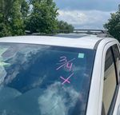
- Vegan
In this case, this car may show that they are picking up for 3 households, and there are 4 children total. The “X” may stand for no meat or no to another specific item previously discussed.
- No Dairy

Example:

Link 2 Feed:
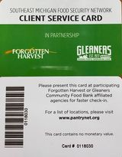
Link2Feed’s food pantry software helps food banks like us and food pantries better understand who is using their services and how to help them. The data collected through Link 2 Feed can help us better allocate resources, food and even target specific nutritional needs to all of the agencies and clients that we serve.

Once a client is registered with the system, they will no longer need to provide all of their individual details at any distribution they attend in the Forgotten Harvest or Gleaners network where Link2 Feed has been implemented. This reduces the wait time and increase the security of individuals personal details. Instead, you can assign a card and number to each client who registers, and you will be able to simply “scan” the barcode of the card each time the client arrives at your distribution.
Forgotten Harvest will provide Link2Feed training to the agency on its usage. Agencies must uphold the Link2Feed terms of service as defined in original login portal. Within 30 days of implementation and training, the agency must maintain client data collection in the Link2Feed system during each distribution.
Every time a client receives USDA product the agency must register the clients using Link2Feed or, if Link2Feed is not operating at the agency, or client refuses electronic signature, the agency must register the client visits using the current USDA Self-Declaration of Income paper register (see example later in this section). The agency must send the completed USDA Self-Declaration form with the Forgotten Harvest driver or submit Link2Feed data after each distribution with Forgotten Harvest within no more than 48 hours. If agency does not submit client data through the Link 2 Feed system or through the submission of USDA Self Declaration sheets within the allotted time, the agency will not receive product from FORGOTTEN HARVEST until it is deemed data capture is back in compliance.
Please note: USDA/TEFAP’s required statements regarding the collection of “Optional” data must be posted so that pantry clients may see the notices regarding Link2Feed data and paper registration locations.

Client Registration with Link 2 Feed:
There are several ways in which a client can register with the Link 2 Feed System:
- Assisted Registration: An agency may choose to assist their clients by enrolling them in the Link 2 Feed database. In this case, you would have a station set up where you could ask and entered questions on a computer or allow for the client to use the computer to complete the questionnaire online.
  - Once the registration is completed you will be able to assign the client an ID# and Client Scan Card.
- Long Form: This is a form created from all of the questions posed on the online registration site, but in a printable format. The client would complete this questionnaire and your agency would enter into the Link 2 Feed system to officially enroll the client in the database.
  - Once the Clients information is entered into the system, you will be able to assign the client an ID# and Client Scan Card.
    - You may assign a card to them before the data is entered, but you will need to record the scan card number on the form before giving it to the client.
    - The card will not work until the data is entered into the system and linked to the card number.
- Short Form: This is a shortened version of the fully inclusive registration process. This is a great method to use when registering clients while they wait in line at a distribution.
  - Once the Clients information is entered into the system, you will be able to assign the client an ID# and Client Scan Card.
    - You may assign a card to them before the data is entered, but you will need to record the scan card number on the form before giving it to the client.
    - The card will not work until the data is entered into the system and linked to the card number.
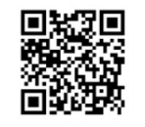
Link2feed.com Using a URL or QR code, clients can register themselves in the Link 2 Feed system via their own personal device such as a computer, tablet or phone. The QR code for this registration process is located on the short forms mentioned above. If using the QR code, the client does NOT need to complete the short form as well, one or the other is acceptable.

  - Once the client completes the registration on their device, instruct them to write down or screen shot their client ID # that will be given to them on their conformation page. You will need to link this client ID # (now in the Link 2 Feed System) with the Scan Card to assign to them.
    - You may assign a card to them before the data is entered, but you will need to record the scan card number on the form before giving it to the client so you can later link the two numbers together.

Rolling Out Link 2 Feed Initial Start and Client Registration at your distribution:
- During the time you would normally be doing client intake you will hand out the enrollment forms to your clients. You might want to include a brief explanation to them:
  - We are starting to use a client enrollment system in order to make your future visits easier and faster for you and all other clients. You can fill out this form here on paper and turn it in as you pull up for your food today. When you return the next time to any Forgotten Harvest food distribution, you will receive a card/number to make your check in faster. By doing this, you will no longer have to provide your contact details on each visit. (suggestion to provide pens for client use)
  - You may also choose to fill the form out electronically by using the QR code on the sheet here. If you do that, please write down the Client ID# that the system will give you upon completion (Pro-tip: have them take a screen shot of the number to save for long term).
  - You will still need to write on the window (or whatever your process is) to signify the number of households. You can simply ask them how many people they are picking up for that day since they will be providing the address/info on the form or online.
- The client pulls up prior to the food distribution:
  - If paper form is used:
    - Have a basket or box to collect the completed forms, have volunteer who is collecting them do a quick glance to make sure all information is completed.
    - If assigning scan cards, have volunteer write the number from the back of scan card clearly on the top of each paper form. Volunteer then gives client the scan card, encourages clients to take picture of the card or Client ID# or to write down the numbers. Informs client these numbers can be used at any Forgotten Harvest/Gleaners pantries, and they will be asked for their card.
    - Indicate number of people in the household on the vehicle as usual process
    - If client picks up for other households, provide a short form for each family/household to be filled out. Volunteer enters the additional households on USDA sheets like normal and informs the driver if they come back with completed forms for each additional family, they too will no longer need to use the USDA sheet.
  - If registered online/QR Code:
    - They will need to provide their Client ID# from their phone/device at this time to you (this is the number they get on the confirmation screen).
      - If you are using a device/scanner, you can now enter their Client ID# in the L2F system to check them in.
      - If not using a device, enter Client ID# clearly on client ID tracking form (you will need to update L2F after distribution with these numbers for check-in).
    - Indicate number of people in the household on the vehicle as usual
    - If assigning scan cards, have volunteer write the number from the back of scan card clearly on the USDA form in the name column, right next to the client ID#.
- Client continues to distribution as normal.
- After distribution is over:
  - All paper registration forms will need to be hand entered into the L2F system as soon as possible. Enter “undisclosed” for any information not asked on the form or not captured. *Anyone issued a scan card must have it entered within their profile.
    - Once profile is complete, enter/check them into the panty.
  - Anyone who registered online via the online link, enter the Client ID# numbers from the Client ID tracking sheet and check them into the pantry.
  - Send all USDA Sheets to Forgotten Harvest for individuals not registered with L2F
- Next/Future Distribution:
  - As clients pull up you will ask:
    - Do you have a scan card or Client ID#?
      - If yes, scan card or enter number into system.
        - If not using an electronic device, write the scan card number or client ID# on the Client ID Tracking sheet
        - Upon completion of panty distribution, enter all numbers into L2F and check them into the pantry (see data entry resource)
      - Check them in for the distribution.
      - Continue to food distribution.
    - If No Card:
      - Did you fill out a registration form last time?
        - Yes: With Device look up client by name or birthdate
          - Check card area, either assign a card to them or delete old and issue new card. Then hit save in the L2F profile.
          - Check in for today’s distribution.
          - Give them the card (tell them to keep it for future visits, encourage taking a picture or writing the number down)
            - Remind them, the card has no monetary value but will help speed up their check in at future food distributions here and at any other pantry with Forgotten Harvest or Gleaners.
          - Continue to food distribution.
        - Yes: With no tech device, write down name and birthdate on Client ID tracking sheet so the person can be found in the system later and checked in.
          - After distribution look up these names/ID’s in L2F and check them into the panty.
        - If no (or if they say yes but you cannot find them in the system):
          - Start process over by giving them a form and having them fill it out or using the QR Code.
Each distribution after you start this process will move faster and better for you.
Once you get to a place where most clients are registered, you may consider creating a line or area for people who are “new” or not yet registered (if you use multiple lines). You will want to always have the registration forms on hand as you will have new people throughout the year.

USDA Self Declaration Forms:
If your agency is not yet using or unable at any point to use the Link 2 Feed system to capture client data, you may alternatively use the current USDA Self Declaration form. These forms must be obtained from your Client Service Specialist in order to ensure the version is the most recent and up to date.
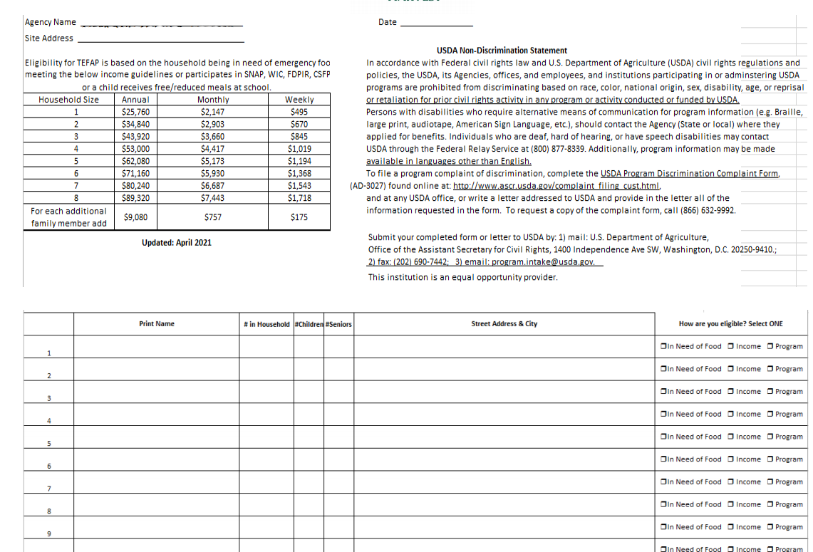
John Smith 6 3 2 1234 Example Street, Detroit MI, 48231 X
Jane Doe 4 0 2 4567 Main Street, Detroit MI 48123 X

In order to use this form, it is important that all data requested is captured. This includes: Name, number of Total Household Members and address of home as well as the eligibility declaration. The number of seniors and children is the home is optional for the client to provide and a client cannot be turned away for not providing this information.
Please Note: If client refuses to fill out or provide any of the required information, you can still provide them with food. We cannot turn anyone away for not providing information. Just enter whatever information they will share on the USDA form. We do NOT verify information collected via an ID or other documents from the client.
Pick up by Proxy:
We often work with small organization who may not have the resources to host their own distributions but do indeed serve and feed a specific group or individuals In these cases, they may be requesting food for too many people to go through your regular Pantry line. Instead, you may want to serve them separately (typically before your pantry opens).

Food Distributions
Determining the quantity of food to be provided to an individual or family is partially up to the partner organization. Food distributions base the amount of food provided on household size and how frequently clients are allowed to visit the pantry. For example, food pantries that restrict service to once per month will generally provide more groceries for each household than a pantry that allows clients to receive service once every two weeks.
When the food arrives, the driver will have a manifest or invoice of the items on the truck including the type of foods and counts:
- Look and see, what is on the truck? How many of what items (you can also refer to the invoice you will need to sign to get a count and idea of what you have).
  - This will help in determining the placement of the food at the site.
    - Larger/heavier items are often placed at the front of the line to make room for them in the client’s vehicle and to not crush lighter weight items like bread or eggs.
    - If you have a low number of volunteers, decide which foods to place next to each other to enable a volunteer to work 2 stations (or more)
    - Cold items should be left wrapped and stacked, to ensure the items that are distributed last maintain a food safe temperature. Open boxes as you go, especially in warmer weather.
    - Pallets/stacks should be spaced so that a volunteer can safely move between the pallets.
  - How many volunteers are needed to dispense the food?
    - If something needs to be re-packed, sorted or bagged, you may want to allocate additional volunteers to work that station.
      - Plan your calculation of how these items need to be bagged or packed based on your anticipated household count and total number of items
      - You can start separate some of these items before the distribution starts to move the process along quicker.
  - What is the mix of products on the truck?
    - Are there similar items?
    - Can similar items be left on the truck until needed?
      - This helps specifically with items that should remain cold or chilled for food safety reasons.
    - Do you have more than 1 pallet of any item? If they are cold products, request that they stay on the truck until the 1st pallet has been distributed.

Allocating the Food
Once you have reviewed your delivery manifest and know the items you are distributing, it is time to calculate the quantities for distribution. For each car/person you will need to know the total number of households they are picking up for that day, for more information on that please see “Client Registration processes on page 12”.
In order to have the best planned and calculated distribution, it is helpful to know ahead of time your typical turnout. Some numbers to know will be:
- Typical number of households served (a household is counted as 4 people at the same address)
- Typical number of Children in households you serve at each distribution
- Typical number of Cars (this helps you estimate the total households per car and so you know ahead of time if your distribution looks like it will have more or less people than normal at the start)
In most cases, the number of items or packages is listed on the outside of the box. You may need to look for it. Keep in mind how much space a person may have at home to store the food when thinking about how to allocate your food.
Examples: Frozen chicken breasts, 50 cases, each with 4 bags.
- Your distribution typically has 100 households served. With 200 bags of chicken (50 x 4 =200), bags. Each family should get 2 bags.

Example: Gallons of Milk: 1 Pallet of Milk, 55 crates
- Each Crate has 4 cartons of milk, this means there is 220 cartons of milk to pass out.
  - You have 90 households typically at your distribution
  - Plan for 2 gallons of milk per household, if there are children in the home, offer an additional gallon per car or household (depending on your typical kids counts).
Example: Cucumbers: pallet of 35 cases, each case has 24 individual cucumbers.
  - Your distribution typically has about 140 households to serve. With 840 cucumbers (24 x 30=840), you can give each household 6 cucumbers.
  - This would be a good item to separate and bag instead of having to count out 6 cucumbers for each household. You can do bags of 6 and 12 (for those picking up for multiple households) and bag them ahead of time for easier and faster distribution.
If you have an abundance of any type of produce, choose a quantity that the average person can work with. Be mindful of home refrigerator sizes. If you cannot distribute all of the food allocated to your distribution, please return the food back to the warehouse through your driver so that it can be used and sent to other distributions.
- Here are some easy guidelines
  - 8 to 10 tomatoes, depending on the size
    - If there are cartons give 2 or three cartons
  - 6 cucumbers
  - 8 peppers
  - 8-10 onions
  - 12 apples or a bag
It is ok to ask someone if they could use more if you have an excess of a particular item but please ask first if they would be able to use it and/or store it.
Special Items
In special circumstances, you may only get specialty food items that will not go far. Bags of popcorn, cereal, sweets or candy. This is the time when you give only one per car and if questioned, explain that you would like there to be enough for EACH CAR, (not family). You can say that it is a special treat that you received and would like to share with everyone in line.
You may also at times get food or items that are specific to children or infants. In this case, you may want to prepare ahead of time by including in that days client intake process the count of children/infants or applicable age group on the cars window along with the household count.
Dos and Don’ts
- Do know your average car/household count ahead of time to properly calculate the distribution of food
- Do write on the boxes/pallets or with a paper how many of each item per household or child
- Do send back any undistributed food to Forgotten Harvest (this helps us to continue to feed others within your community)
- Use minimum intake requirements. Make it easy for people to get food.
- Distribute food for use by the needy, ill, children and seniors.
- Distribute food to clients free of charge.
- Refer clients to other partner organizations or to 211oc.org when they have a
  - need you cannot meet.
- Record number of people being served and turn in your reports.
- Follow all Safe Food Handling procedures closely.
- Treat those who come to you for food with respect and dignity.
- Don’t attempt to hand out all food to just get rid of it
- Don’t unwrap/unbox all food and pallets at the start
- Don’t ask for or solicit donations of any kind in exchange for food
- Don’t require or request participation in volunteer activities, parishionership or other needs in exchange for food
- Don’t redistribute product to other non-profit entities including pantries or meal providers, regardless if they are a current member of the Food Bank without prior approval
- Don’t sell or use product from the Food Bank in exchange for money, property, or services.
- Don’t use product for fundraising.
- Don’t solicit donations of any kind from your clients.
- Don’t make it difficult or embarrassing for individuals who are seeking help.

Set up and traffic control
Having a lot large enough is only part of the plan for an effective distribution. Making sure that you have adequate room for cars to drive through, pallets of food to be set up, and to be able to do it in a safe and well-spaced area is essential to consistent traffic flow and safety of volunteers and staff.
Below you will find some pictures of actual distributions as well as an “ideal” layout to help give an idea of what your mobile distribution may look like:
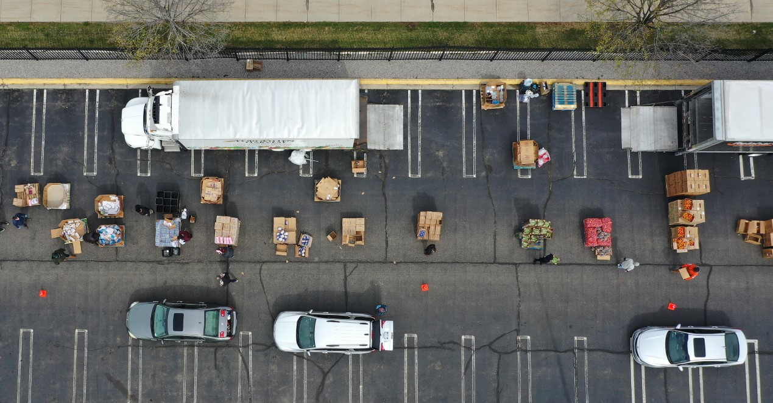
- Pallets spaced so volunteers can easily and safely walk between
- Traffic Cones separate volunteers/pallet locations from cars driving through for safety reasons
- Forgotten Harvest Trucks in close proximity for loading and unloading additional products

- Parking lot is being used as an area to
register and check in clients
- One entrance and one exit separate from
each other
- No traffic through distribution area for
safety reasons

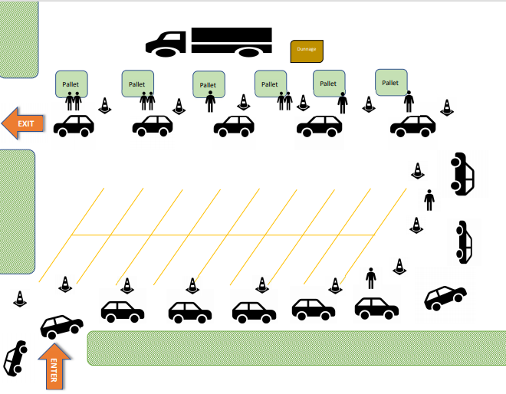
- Entrance and Exit Points should be two different locations and allow for easy traffic flow. Steps should be taken to control the flow of clients in and out of the distribution area and limit the areas that are accessible to their vehicle. This can be accomplished by placing “barriers” (caution tape, cones, etc.) that direct and control client flow, their vehicles and other traffic.
- 1-2 volunteers at each food pallet for distribution
- Volunteers can assist in directing clients to the proper areas
- Collect garbage and dispose of onsite if suitable containers are available, or collect garbage and return it to the food bank for disposal (this is sometimes referred to as “dunnage”
- Mobile food pantries bring a lot of excitement and clients may start arriving early. Be aware of the additional traffic this creates. Adults must keep their children attended at all times
Create a schedule for your staff and volunteers ahead of time so that everyone is on the same page and aware of the time commitments. A sample distribution schedule may look like this:
Sample Food Distribution:
Runs from 9:00 am -11:00 am
8:00 am: Some volunteers arrive to set up traffic control (cones, barricades, signs, etc.) as well as to start Client Registration
8:30 am: Forgotten Harvest Truck arrives with food and unloads (this process takes approximately 30 min depending on the size of your distribution).
8:45 am: All volunteers in place at this time to begin organizing their area and calculating their item distributions per car/household
9:00 am: Start food distribution once truck is fully unloading and volunteers are stationed at each pallet/food location.
Throughout the Distribution time, monitor the number of cars/households in line and adjust food allocation as needed.
10:00 am: If it is extremely hot or cold, plan a break for new volunteers to step in so the current ones can warm up or cool down.
10:45 am: Start to monitor the end of the line and be prepared to “close down” or block the end of the line to ensure your distributions can end on time.
11:00 am: Volunteers to start breaking down boxes, consolidating garbage/dunnage and assisting the driver if needed in organizing any remaining food to be re-loaded to the truck.

Weather Conditions that may impact Mobile Pantries
When it is hot….
If the weather is hot, down stack your frozen items and make sure that the food is put back on the truck keeping it properly refrigerated. Only open the top boxes of frozen products to keep the food as cold as possible. The same goes for milk and other dairy items. Volunteers sometimes like to start opening boxes of frozen food, please, have them refrain from this until the last possible minutes to keep the temperature integrity of the product. Only open the necessary boxes on each layer of product to dispense.
Make sure you have plenty of water and cold drinks on hand to help volunteers stay comfortable through the distribution. You may also want to consider to have enough volunteers to have “floaters” or even shifts so people can take turns going inside to cool down or take a brief break.
When it is cold…
If the real temperature is 10°F including wind chill of 5mph making the temperature 1°F or conditions seem dangerous, regardless of temperature, building and road conditions, freezing rain, snowstorms, or snow accumulating more than 6 feet, the recommendation is to close the outside ran distributions. This determination should be made by noon the business day before and all volunteers should be contacted. Forgotten Harvest will also update the website and social media channels as appropriate.
You may want to make sure you have plenty of warm drinks (coffee, tea, hot chocolate) on hand to help volunteers stay comfortable through the distribution. You may also want to consider to have enough volunteers to have “floaters” or even shifts so people can take turns going inside to warm up or take a brief break from the cold weather.
When it is raining….
If it is raining, keep the plastic wrapped on the pallet and only remove as you go. This will keep the boxes dry and easier to handle. Soggy boxes may come apart and product could fall out and possibly end up on the ground.
If it is thundering and lightning, you must suspend the operation until the weather has cleared and it is once again safe to return to operations.
Other Considerations for Distributions:
Often we are approached by various other organizations, groups or companies in our area who want to partner with us and provide information to our clients about their programs and services.
- We do not place items, give-a-ways or literature from other organizations in the boxes or with the food that we are distributing
- We/you can allow certain organizations to have a table/booth or even go car to car to talk or share information about their programs/services, however some limitations on the types of programs and/information being shared needs to be followed:
  - No political solicitations or campaign may be permitted to take place at or during a food distribution
  - No company or organization should be selling items or taking payment from clients for services
- Some organizations or services that we have partnered with in the past include:
  - Organization offering free health services
  - Discounted or free services for people who meet income guidelines (cell phones, internet, etc.)
  - Information about community programs or assistance
- When in doubt, please contact your Client Service Specialist for more information or guidance.

Volunteers:
Volunteers are essential to having a smooth and efficient food distribution. It is important that all volunteers have a clear understanding of their expectations, the role they will have that day and a feeling of appreciation for the help they are providing.
Involving Clients in your Volunteer Program can be a difficult task. There are certain aspects that you need to be sure are clear to the client/volunteer to ensure fair service to everyone. Therefore, it is important to have in place some type of policy.
Partner Organizations may provide food to the ill or needy volunteers and/or staff if they are truly needy. If volunteers receive any food, they are not allowed preferential treatment and cannot “cherry pick” items before the general public. They must follow the same procedure as the general public to receive food assistance. Agencies may not “reward” volunteers for their labor with food obtained from the Food Bank. Partner organizations must find other methods of expressing appreciation to volunteers. Volunteers are not entitled to food because of their service.

Some policies on client volunteer involvement may include:
- Have a policy that states the distribution manager must assist the client/volunteer when they get food from the distribution.
- Separate their needs as volunteer and as client
- Explain non-negotiable rules
- Do not have volunteers “skip” the line ahead of other pantry guest
- All volunteers taking food must also register with the distribution via Link 2 Feed or USDA Client Intake forms
Ways to use Volunteers to help with your Distribution:
- Client Intake (Link 2 Feed Registration or USDA Sheets)
- Greeting/Traffic Direction
- 1-2 volunteers per item being distributed
- 1 volunteer to assist with picking up empty boxes/wrappings as the distribution is happening
- 1 runner to assist with various needs
- 1 volunteer to watch/count cars and re-allocate allotted amounts as the client totals vary
Volunteer Hospitality:
When hosting volunteers, it is important that we ensure our volunteers are comfortable.
- Please provide water especially during the hot summer days and warm beverages during the winter.
- Offer shelter during inclement weather, provide areas to cool off during the hot summer days and warm stations during the winter.
Volunteer Recruitment Ideas
Contact and work with the following to post your volunteer opportunities:
- Your Church’s bulletins, special announcements during service, or surrounding churches
- Local YMCA or recreational centers/gyms
- Social and Civic Clubs/Organizations (Lions, Optimists, Eagles, Chamber of Commerce, Moose, etc.)
- Local grocery stores
- Local libraries
- Post a sign at your distribution letting clients know you have opportunities for volunteers
- Share on all Social Media channels
- Check with your local schools or colleges about students who need community service hours
There are several online volunteer portals that are free of charge to post your volunteer opportunities.
- https://www.justserve.org/
- https://www.gozaround.com/
- https://createthegood.aarp.org/
- https://www.volunteermatch.org/
If your distribution is in need of additional volunteers, please contact your Client Service Specialist. We may be able to assist you in recruitment of additional volunteers on a temporary basis.
Appreciation
It is always a great idea to acknowledge your volunteers for their service, especially your regulars. Volunteer Appreciation Week is April, but you don’t have to wait until then. Here are some examples.
- Thank You cards or notes
  - Sometimes a simple handwritten or personal appreciation is the most appreciated form of recognition
- Gift Cards for a cup a coffee or a small meal
- T-shirts or other items branded for your organization. People like to share and be proud of where they volunteer. As a bonus, branded items help you to spread the word about your organization and the great work that you do.
- If you are a church, post their picture with a caption in your newsletter or bulletins
- Offer snacks and/or beverages during the volunteer opportunity (everyone loves bagels and donuts!) *Please note that this cannot be food given for your distribution by Forgotten Harvest, these items must be supplied by the Agency.
- Highlight and recognize your long-time volunteers based on hours provided or years involved.
- Give a shout out to your volunteers on Social Media, tell their story and share why they are engaged.
Volunteer Records
When working with volunteers you should keep accurate records of the volunteer’s service dates, hours, and duties performed. You should also keep documentation if you require a waiver, an application, reference or background check.
Recommendation:
- Invest in web-based volunteer software or create a database if you have a large number of volunteers monthly. The following software programs can help store you records: Galaxy Digital, CERVI and Volunteer Hub.
- If you have a small number of volunteers monthly, SignUpGenius will help you managing your event, and allow volunteers to sign-up.

Food Safety:

Forgotten Harvest is committed to providing access to safe, wholesome food through our network of almost 200 agency partners. Food safety must continue to be an essential foundational piece of our work and an enduring commitment from all that are involved.

As the landscape of the product mix continues to change, it requires our agencies to develop more disciplined food safety practices related to how food is handled through the process. Forgotten Harvest is dedicated to providing opportunities for our partners’ continued development of its food safety expertise. It is our commitment to establish and maintain standards that steward our donors' resources in order to provide clients with safe food.

To ensure your distribution is in compliance with the highest food safety standards for your agency and clients we encourage you to review all of the food safety resources readily available to you through this section.

ServSafe® Certification

ServSafe® is a food and beverage safety training and certificate program administered by the National Restaurant Association. The program is accredited by ANSI and the Conference for Food Protection. For agency partners to receive food from Forgotten Harvest, your agency must have a ServSafe Manager Certification or ServSafe Food Handler for Food Banking certificate (administered by Forgotten Harvest) on site at each location where we provide food. Facilities that are preparing and serving food provided by Forgotten Harvest, must have a ServSafe Manager on site during all preparation and distribution of food, regardless, if your facility is inspected by a local, regional, or state agency.

Forgotten Harvest and Feeding America require the that the following guidelines are strictly adhered to in all locations that are storing food/product onsite. These guidelines include, but are not limited to the following:
- Store food 6 inches off of the floor on pallets, shelves or tables in a clean, dry, area
- Toxic/Chemical items are stored separately and away from food items
- Pest control and mitigation management
- Maintain refrigerators and freezers at a safe temperature and are kept clean
  - Cooler unites should be under 41 degrees
  - Freezer units should be under 0 degrees
  - Maintain accurate temperature logs and keep thermometers in all units
- All food should be stored away from heat sources (dry storage temperature should be no higher than 76 degrees)
- Rotate all stock, using first-in, first-out practices
Additionally, Forgotten Harvest requests for our partners to:
- Log temperatures of freezers and refrigerators (requirement of TEFAP if receiving USDA Products).
- Log pest findings and control practices (requirement of TEFAP if receiving USDA Products).).
- Have handwashing facilities nearby or another method of sanitization.

Policies for a safe food distribution
- Once a food item is distributed to clients/guests, it may not be returned – even if clients explain that they will not need/will not use the item.
- Identify the steps needed for employees and volunteers to safely handle and distribute food. Provide the means to wash hands with soap and hot water and provide single-use towels for hand drying. Rely on hand sanitizer as a back-up.
- Provide disposable gloves to workers and volunteers; in some cases, additional protective clothing may be warranted (for example plastic aprons).
- Evaluate on-site volunteers to determine if they exhibit underlying health conditions that would prohibit them from handling food.
- Establish the measures needed to control the flow of products and people throughout pantry setup and product distribution process. Control access to the food to prevent any intentional or accidental contamination.
- Provide a sufficient number of single-use containers (single-use bags, boxes) for client use to carry food. Do not reuse boxes that show signs of contamination (wet, stained, dirty, or broken).
- Provide enough single-use containers so that food can be safely segregated; keep meat, poultry and seafood separate by species, separate from other refrigerated food and produce, and also separate from RTE and prepared foods. Avoid reusing packaging gleaned from the food in distribution (e.g., packaging from bulk repack items).
- Maintain foods at the proper temperature for the duration of the distribution. Unload only as much product as needed to start food distribution and then replenish the supply.
- Maintain sanitation at the distribution site; clean and sanitize food contact surfaces (such as tables) during product changeovers and at the conclusion of the distribution. Collect garbage and dispose of onsite if suitable containers are available or collect garbage and return it to the food bank for disposal.
- Maintain product integrity throughout distribution. Collect any damaged or compromised product and dispose onsite or return to the food bank for disposal. Do not distribute damaged or compromised product.
- Consider providing safe-handling instructions to clients, including information on minimizing cross-contamination and spoilage if applicable.
- Monitor the duration of the distribution process. Be prepared to suspend product distribution if necessary and move foods to an appropriate temperature-controlled setting.
Recalled Foods:
Forgotten Harvest tracks recall information pertaining to the region and communicates it to all Agency Partners. Item(s) on the list may not have been distributed through the Forgotten Harvest, but a partner may have received it through other food streams. In the event a recalled item was disbursed through the Forgotten Harvest the following actions will take place:
- Forgotten Harvest staff will call each partner who has received or may have received the recalled items within 24 hours of notice.
- Forgotten Harvest will verify that the product was received and will advise on disposal methods.
- Forgotten Harvest may also advertise the recall through other means, such as mail, email, newspapers or radio if necessary.
Partners should establish a recall procedure, including plans for notifying clients and disposal of product. It is the responsibility of the partner to notify clients who may have received a recalled item. This can be done via social media, calls, emails, flyers at the program site, etc.

Unruly Pantry Clients:
Forgotten Harvest wants to support your commitment to provide emergency food to your neighbors in a safe, respectful environment. We do not expect you or your volunteers to work with pantry clients that are unruly, or aggressive such that they cause an unsafe situation.
Under federal anti-discrimination laws, businesses can refuse service to any person for any reason, unless the business is discriminating against a protected class. In administering these unfortunate circumstances, FH requires its pantries to comply with the USDA Anti-Discrimination Policy.
For example, if a pantry client is causing an unsafe disturbance or is a health or safety hazard to other patrons, or is aggressively accosting other staff, volunteers, or pantry clients yet refuses to stop when asked, then the pantry may refuse service.
- ACCEPTABLE: Refusing service to a pantry client because they’re causing an unsafe disturbance or not respecting the requests of the pantry staff and/or other clients to abide with the pantry’s policies.
- NOT ACCEPTABLE: Refusing service to a pantry client because the client is dressed unlike others receiving service, is unusually tall, or wears thick glasses. Please be mindful that FH’s agencies must comply with USDA Anti-Discrimination Policy.
If you find yourself in that difficult scenario, it’s important that you know how to handle it correctly. Here are a few best practices to keep in mind:
- Start with De-Escalation First: Sometimes refusing service is unavoidable, but it shouldn’t be your first action, unless a pantry client is posing an immediate threat or safety concern. Assuming this situation is safe: calmly approach the client to ask if you can resolve the issue respectfully and calmly. If the situation is unsafe, you should contact local law enforcement immediately.
- Provide Clear Reasoning: If you need to exercise your right to refuse service, provide a direct, legitimate reason for why you cannot serve them. This serves as verbal confirmation that you aren’t discriminating.
- Refer to an Agency Policy: It’s even better if you can refer to a written policy for your organization if you have one. For example, if your policy states that you will not serve pantry clients who verbally harass or threaten your employees or volunteers explain that policy to the pantry client and explain that they need to leave.
- Document the Incident: Once the client has departed and the situation has been addressed, create written description of what happened—including the date and time, what occurred to prompt intervention, who witnessed that interaction, and specially what was said and done. You may find that having a written record is important in the future. Please share this information with your FH Client Service Specialist as well.
If you still are not sure if you are allowed to refuse service to a client, please contact your FH Client Service Specialist for additional resources or assistance.

Monitoring and Compliance
No less than once every 2 years, a Forgotten Harvest Client Services Specialist will conduct an onsite inspection at each location of our agency partners. This inspection is meant to be a collaborative effort between Forgotten Harvest and your agency to make sure we are serving our clients and the community in the best way possible.
Some of the items that will be reviewed and inspected during this monitoring will be:
- Updates to records/files
- Food Safety Regulations
- Food Storage Inspection
- Pest Control Management check
- Records and Data
- Review of Policies and Procedures
Partners found to be in violation of any Forgotten Harvest policies and procedures outlined in this handbook and/or partnership agreement will be subject to corrective action, suspension and/or termination.
Corrective Action
A plan created by a Client Service Specialist and/or Leadership and the partner to return to compliance. During this time partners may still be eligible to receive food deliveries, and/or conduct food rescue pick ups. A corrective action ends when the plan is complete and successful, or the partner is suspended/terminated.

Suspension/On-Hold Agencies
A period of time not exceeding three months when a partner is temporarily not eligible to receive product. During suspension partners cannot receive food deliveries, or conduct food pickups. Partners will be notified of their suspension status via email or letter, including the cause and next steps. Partners maintain an active status with Forgotten Harvest while on suspension. Partners’ suspension ends when one of the following occurs:
- Partner works with Client Service Specialist to remedy the violation(s).
- Partner voluntarily terminates their partnership with Forgotten Harvest.
- Partner has been terminated by the Client Services Manager if violation(s) is not remedied. Partner will be notified of their termination in writing.
A suspension or corrective action extension may be authorized by Client Services Manager if the partner/agency proves progress has been made and plans are in place to remedy the violation(s) in a timely manner.

Termination
If non-compliance is not remedied or Forgotten Harvest staff determines partner does not actively engage in the mission to end hunger, Forgotten Harvest staff can terminate partnership. Partner will be notified of their termination in writing.
When able, Forgotten Harvest will notify in advance of the termination of the partnership. In these cases Forgotten Harvest will help to provide the clients from the pantry with a flyer or other similar information to direct clients to the nearest or most convenient food distribution(s) within our network.
Complaints
Complaints received by Forgotten Harvest against a partner will result in Forgotten Harvest involvement. Complaints received will be documented in writing and kept in the partner’s file. All complainants will remain absolutely confidential. Client Services staff will immediately address the complaint with the partner and/or sponsoring organization. If the complaint shows a violation against the Forgotten Harvest partnership agreement, the Client Services staff will create a corrective action plan for the partner to complete. Partners who fail to comply with the corrective action plan will be placed on suspension. If Forgotten Harvest receives more than three complaints against a partner/agency in a 12 month period, partnership may be subject to termination.

Annual Agency Conference:
Each fall, Forgotten Harvest holds a conference for all of our Agency Partners. All active Agencies are required to attend the Annual Agency Conference by sending at least one representative from their organization. The purpose of the conference is to meet your fellow network of Agency Partners, get important updates and information about Forgotten Harvest and learn about policies, practices or procedures to enhance and help with your food distribution efforts.

Additional Resources:
Any general issues, questions or concerns can be handled by your Client Service Specialist:
Robbya DuBose
Client Services Specialist
Cell Phone: 248.508.7691
rdubose@forgottenharvest.org

Leslie Quasarano
Client Services Specialist
Cell Phone: 248-881-9937
lquasarano@forgottenharvest.org

Dawn Sketch
Client Service Specialist
Cell Phone: 248-234-0017
dsketch@forgottenharvest.org

If your issue is urgent and you are unable to reach your Specialist:
Krista Poole
Client Services Manager
Cell Phone: 248.506.6523
kpoole@forgottenharvest.org

Kelli Kaschimer
Director, Volunteer and Client Services
Office: 248-268-7775
kkaschimer@forgottenharvest.org

SUPPLEMENTAL RESOURCE MATERIAL (Click for Links)
- Agency Agreement
- 101 Ways to Recognize Volunteers
- Site Distribution Procedures
- Civil Rights Form for Volunteers
- And Justice For All Poster – English
- And Justice For All Poster – All Other Languages
- TEFAP HH Info Collection Form (English)
- TEFAP HH Info Collection Form (Spanish)
- TEFAP HH Info Collection Form (Arabic)
- TEFAP HH Info Collection Form (Chinese Simplified)
- TEFAP HH Info Collection Form (Vietnamese)
- Written Notice of Beneficiary Rights
- Distribution Hours Sign
- Find Food Flyer
- Food Distribution Flyer Template

LIMITED ENGLISH PROFICIENCY RESOURCES:
- Language Identifier
- Limited English Proficiency Planning Tools
- I Speak Cards
- Language Access Plan
- Five Steps to Effective LEP Communication
- Tips of Effective Language Program

LINK 2 FEED
- Link2Feed User Manual
- Initial Launch Day Directions
- Adding Household Members
- Client ID Tracking Sheet
- Short Form
- Sample Intake Script
- Logging into Link2Feed

FOOD SAFETY:
- Cold Food Storage
- Cross Contamination Info
- Daily Temperature Log
- Food-borne Illness Information
- Food Product Dating

SAMSUNG PRO ACTIVE TAB]
- Technology Use Agreement
- Samsung Help Page
- Samsung Galaxy Tab Active Pro User Manual

