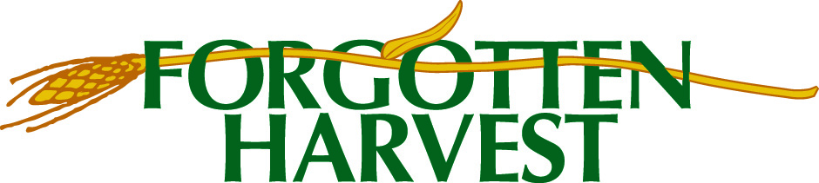

Agency Capacity Grant Program
Deadline to apply for funding in Round 3: September 1 at 11:59 pm
What holds your agency back? What new equipment, facility repair or improvement, or other investment would make it easier and safer to distribute food? What could you do to give your clients more choice and dignity? That is what this grant program is for.
Tier 1 MAINTAIN – up to $40,000 for improvements that maintain your current food distribution
Tier 2 EXPAND – up to $40,0000 for improvements that increase the amount of food you distribute or the number of people you serve
What you can ask for | Costs that these grants will not fund
Capital Equipment – Stoves, Freezers, Etc.  Facility Improvements/Infrastructure  Supplies for New Programs/Expansion  Training for Staff or Volunteers  Staff Time for Project Management or Outreach  Labor for Construction/Implementation  Data Collection Systems  Marketing or Communications  Vehicles | Normal Operating Costs  Staff that are Part of Normal Operations  Supplies for Ongoing Operations  Buying Food  Volunteer Stipends or Incentives  Improvements that are Not Primarily for the Food Distribution Program  Fundraising Costs  Advocacy or Lobbying  Overhead or Contingency

It is an easy online application. Here is what you need to explain to tell your story:
- Who are your clients and how do you serve them?
- What challenge or problem will your project solve?
- What will you do to improve this situation – process, timeline for the work
- Who will do this work – staff or contractors?
- What is your budget, and how do you know what the costs will be?
- If an ongoing project, how will you sustain the work after the grant ends?
Have questions? Need the link to apply? Contact:
Maud Lyon, Capacity Grant Administrator
313 715-6413 mlyon@forgottenharvest.org

