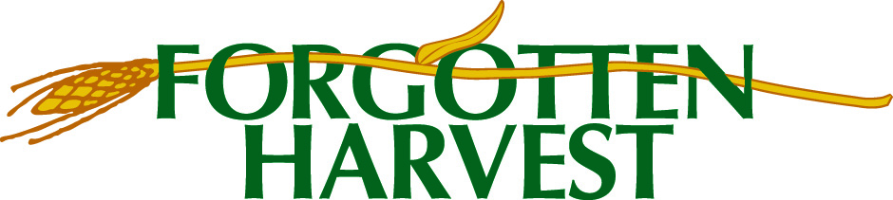

SURVEY OF PARTNER AGENCIES THAT DID NOT APPLY FOR A CAPACITY GRANT

Agency Name (Optional)_____________________________________________________________
In Round 2, we received 53 applications for the Forgotten Harvest Capacity Grant Program – yet there are over 200 partner agencies. If you did NOT apply in Round 2, this survey is for you!
Below are some possible reasons why partner agencies may not have applied for a grant. Please check all that apply to your agency.
- We never heard about the opportunity for funding.
- We heard about it, but missed the Zoom orientation sessions.
- We were too busy with other work and couldn’t devote time to making a proposal.
- We couldn’t find the link to the online application form.
- The online grant application was confusing and we weren’t sure how to proceed.
- We started a draft application but never finished it.
- Our agency couldn’t get our project plan together in time.
- Our church or parent organization had other priorities and didn’t want us to apply.
- Our agency didn’t have a project to propose.
- We weren’t sure what we should ask for.
- No one in my agency is comfortable writing a grant application.
- We don’t apply for grants, this is a new skill set for us.
- We didn’t believe we would be successful – after all, not every proposal gets a grant.
- Preparing a proposal is too much work/too demanding - we thought our time was better spent elsewhere.
- We didn’t apply in Round 2 but plan to apply in Round 3 or other future rounds.

Is there any other reason that you did not apply? If so, tell us what it was.
Your responses will help us to improve the grant program. Thank you!

